**INFO-3111 Summer 2023 – Checkpoint #2**

|  |
| --- |
| **Due:** At the start of class, **12:00 PM (noon), Thursday, May 11th, 2023** |
| **Submit:** Your screenshot to the submission folder in FOL |
| **Worth/weight/mark value:** approximately 1%  (There will be up to 12 checkpoints, *all together worth 10%*, and the lowest two marks (including marks of zero/no submissions) being dropped (not included in your mark). |

This is the “triangle of death”:

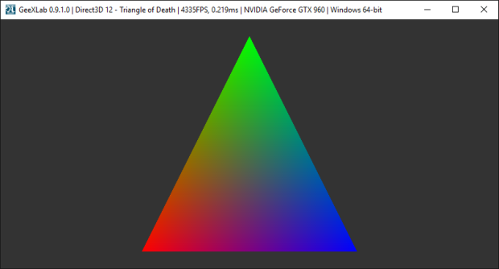

**You need to show one of the “PLY” models as a wireframe.**

There’s a bunch of them under “Resources/PLY Models” in the git hub repository.

The model needs to be:

* Wireframe (*not* “solid”) rendered.
* Some colour that I can see it (yellow, white, whatever – something bright)
* Scaled and or positioned (or the camera moved) so that it fills the entire screen.

Submit a short **video** showing:

* Visual Studio running with your code.
* Somewhere on the screen it should have your name and student number.
* The program starting and showing the model.